Emergency and Vet Clinics Providing Full Service Veterinary Care near The Spayed Club

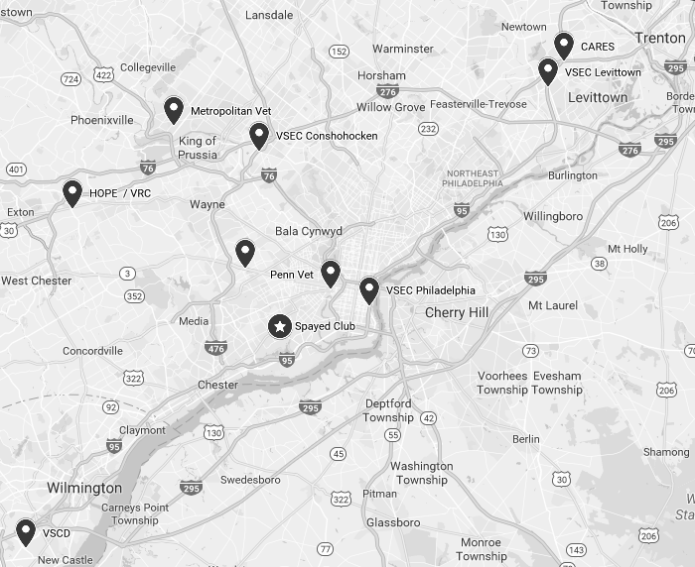

Philadelphia Animal Hospital: 7401 Holstein Avenue, Philadelphia PA 19153. 215-724-5550.
Prospect Park Veterinary Clinic: 903 Lincoln Ave. Prospect Park, PA 19076 610-461-7887.
Penn Vet: 3900 Spruce Street, Philadelphia, PA 19104. 215-746-8911. *OPEN 24/7
VSEC Philadelphia: 114 South Front Street, Philadelphia, PA 19047. 267-800-1950. *OPEN 24/7
VSEC Conshohocken: 625 Ridge Pike, Conshohocken, PA 19428. 484-567-7999. *OPEN 24/7
VSEC Levittown: 301 Veterans Highway, Levittown, PA 19056. 215-750-7884. *OPEN 24/7
Keystone Vet: 1200 West Chester Pike, Havertown, PA 19083. 484-454-5412. *OPEN 24/7
VSCD: 290 Churchmans Road, New Castle, DE, 19720. 302-322-6933. *OPEN 24/7
Metropolitan Vet: 2626 Van Buren Avenue, Norristown, PA 19403. 610-666-1050. *OPEN 24/7
HOPE: 40 Three Tun Road, Malvern, PA, 19355. 610-296-2099. *OPEN 24/7
CARES: 2010 Cabot Blvd West, Suite D, Langhorne, PA 19047. 215-750-2774. *OPEN 24/7
VRC: 330-340 Lancaster Ave, Malvern, PA, 19355. 610-647-2950. *OPEN 24/7

