My pet has fleas! How can I get rid of them?
There are 3 steps to getting rid of fleas on your animals:
- Kill the adult fleas:
  - Apply a good quality flea medication (see below). This will kill the adult fleas living on your animals over the next 12-24 hours.
  - Make sure you treat every dog and cat in the house, even those that don’t seem itchy.
  - If you have animals that cannot be treated (such as very young kittens or puppies), bathe in Dawn dish soap.
- Kill the immature fleas:
  - Flea eggs and larvae live in the house (floors, linens, furniture) not on the pet.
  - Vacuum as often as possible for the next 3 months, and throw out or empty the vacuum bag frequently.
  - Wash all linens, sheets, towels, and pet beds in hot water and dry on full heat.
  - Frontline spray can be used in problem areas around the house.
  - If you have a severe infestation, consider hiring an exterminator.
- Break the cycle:
  - Fleas have a long life cycle and can lie dormant in carpets or other fabric for several months.
  - Continue flea treatments on all animals every month for at least 3 months! It typically takes 3 monthly treatments to completely eliminate fleas from the home.
  - Continue using monthly preventative to avoid reinfestation.

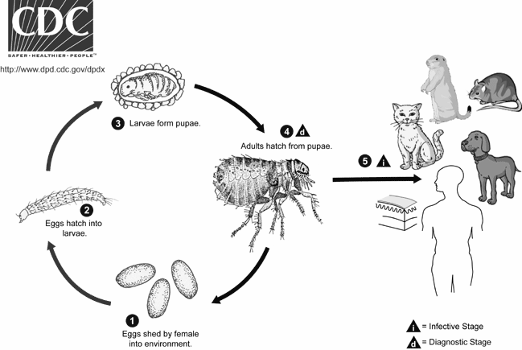

What flea products should I use?
- General info:
  - There are many different types of preventatives: topicals, collars, and edible medications. We recommend buying from your vet’s office to get the best product.
  - If you are not buying prevention from your local vet’s office, be careful what you buy: there is very little regulation of over the counter flea products and many don’t work or are harmful to the pet.
  - Avoid Hartz products, as many are extremely toxic to pets.
- Topical products:
  - Topical products are liquids that are applied to the pet’s skin once monthly.
  - Don’t bathe the pet 48 hours before or after treating with a topical -- it needs the skin’s natural oils to be absorbed properly.
  - Reliable products include K9 Advantix II (dogs only!), Advantage II, Revolution, Bravecto Topical (only topical treatment which lasts THREE months per dose - only 4 doses needed a year!), and Activyl.
- Collars:
  - Most flea collars are toxic or don’t work. We frequently see flea-infested pets wearing flea collars!
  - The only collar proven to be safe and effective is the Seresto brand. It is effective for 8 months; you can buy it here as well as in pet stores such as Petco or PetSmart.

- Edibles:
  - Edibles are a great option for pets that dislike receiving topical treatments.
  - Typically come as a flavored chewable tablet.
  - Reliable products include Nexgard (monthly treatment) and Bravecto (each treatment lasts for three months - only 4 tablets needed in a year!)

What if it’s winter? What if my pet never goes outside?
- Even in cold months, fleas can live year round indoors.
- It only takes one warm day for fleas to come out of hibernation and jump on you or your animal.
- Indoor animals get fleas, too. They can enter the home from nearby wildlife or stray animals. They can come in through doors, windows, and screens, or can hitch a ride on your shoes.
- The best way to avoid fleas is to use a preventative as directed year round on every pet in the home.

The best way to treat fleas is to prevent them from
ever happening!

